|  |  |
| --- | --- |
| **Information Delivery Specifications**  **IDS** | |
| **IDS Bingo Berlin**  **This IDS contains specifications for every facet. Every facet has specifications that are simple to verify basic checkers as well as specifications containing regular expressions.**  **The results can be checked on the Bingo scorecard.** | |
| **Version:** | 1 |
| **Date:** | 24/09/2025 |
| **Author Email :** | menno@aronsengelauff.nl |
| **Milestone:** | Technical Review |
| **Purpose:** | IDS written for 'ILSOenE_PoC-model.ifc' to test IDS tools for creating and validating specifications. |
|  |  |
| Copyright: Arons en Gelauff architecten / BIMvoice | |

Created with usBIM.IDSeditor by ACCA software S.p.A.

# **Specifications**

## **ATTRIBUTE: IfcProjectedCRS must be a valid EPSG code - ATT01**

Checks if the model is placed onto the correct coordinate system <https://standards.buildingsmart.org/IFC/RELEASE/IFC4_3/HTML/lexical/IfcProjectedCRS.htm>

IFC versions: **IFC4X3_ADD2 IFC4**

**The model MUST contain entities that have**

- IFC class **IFCPROJECTEDCRS**

**that MEET the following requirements**

- MUST HAVE attribute **Name** **= EPSG:28992** (Instructions: Choose the EPSG-code for your model here: https://epsg.io/28992Change it to something else to see if the specification works.)

**Instructions**

If your tool does not support this entity, skip this specification.

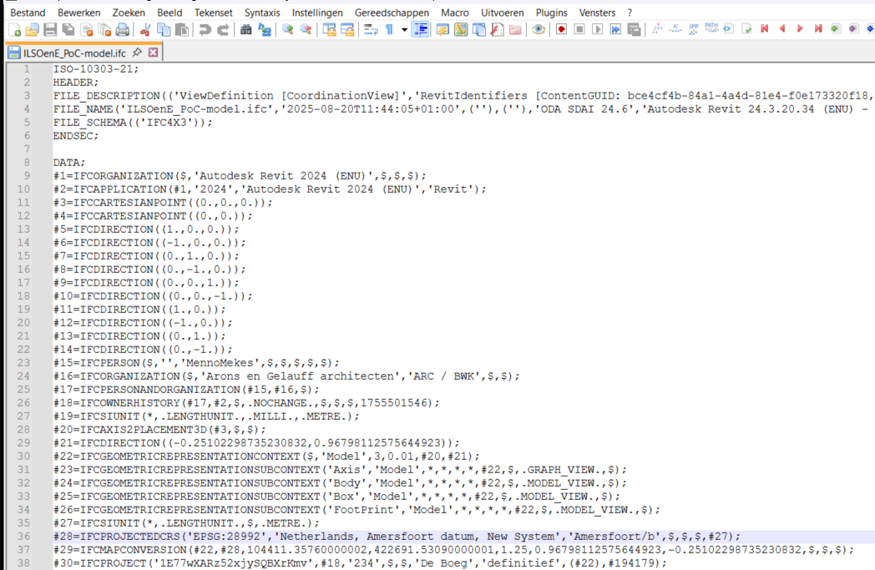

**Result**

The specification should pass. Try to change the EPSG to something else to find out if you get a mistake.

## **ATTRIBUTE: Attributes in IfcMapConversion must be present - ATT02**

Checks if the model is placed on coordinates <https://standards.buildingsmart.org/IFC/RELEASE/IFC4_3/HTML/lexical/IfcMapConversion.htm>

IFC versions: **IFC4X3_ADD2 IFC4**

**The model MUST contain entities that have**

- IFC class **IFCMAPCONVERSION**

**that MEET the following requirements**

- MUST HAVE attribute **Eastings** (Instructions: Attribute must exist)

- MUST HAVE attribute **Northings** **= 422691.5309** (Instructions: Attribute must exist)

- MUST HAVE attribute **OrthogonalHeight** (Instructions: Attribute must exist)

**Instructions**

If your tool does not support this entity, skip this specification.

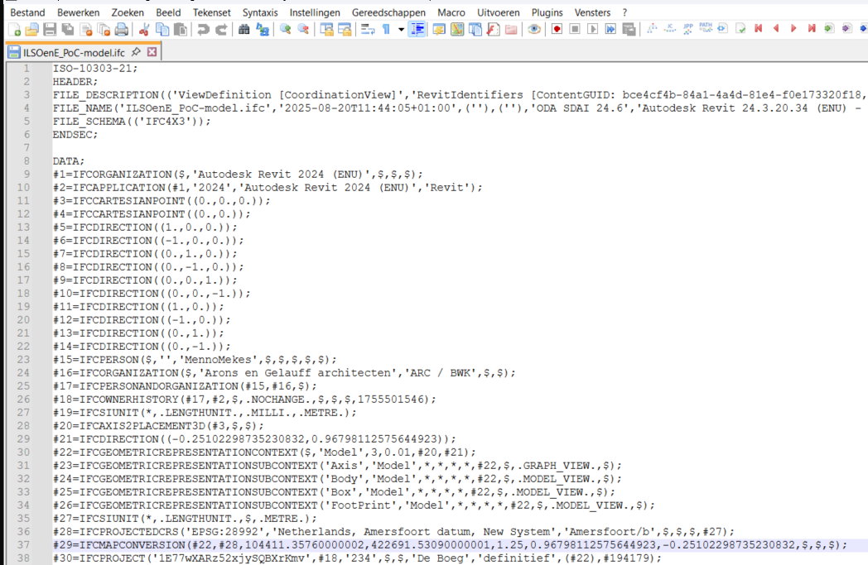

**Result**

The specification should pass. When it fails the Northings you can check the notation. Did you enter meters, a point or a comma. Your tool either does not support this or do you need to change something in the notation.

## **ATTRIBUTE: Attributes in IfcMapConversion cannot be 0 - ATT03**

Checks if the model is placed on coordinates <https://standards.buildingsmart.org/IFC/RELEASE/IFC4_3/HTML/lexical/IfcMapConversion.htm>

IFC versions: **IFC4X3_ADD2 IFC4**

**The model MUST contain entities that have**

- IFC class **IFCMAPCONVERSION**

**that MEET the following requirements**

- MUST HAVE attribute **Eastings** **< 0** (Instructions: Attribute must be greater than 0(the coordinates must be set but cannot be at 0,0,0 for the model to be at the correct location)(This test is less than 0 in order to generate a mistake))

- MUST HAVE attribute **Northings** **> 0** (Instructions: Attribute must be greater than 0(the coordinates must be set but cannot be at 0,0,0 for the model to be at the correct location))

- MUST HAVE attribute **OrthogonalHeight** **≥ 1.25** (Instructions: Attribute must be greater than or equal to 1,25m(Actually it should just be 1.25m but this is to test the different bounds.))

**Instructions**

When bounds do not work, skip this specification.



**result**

the specification should pass.

## **ATTRIBUTE: list of correct naming of building storeys - ATT04**

validates the naming of building storeys in a list <https://standards.buildingsmart.org/IFC/RELEASE/IFC4_3/HTML/lexical/IfcBuildingStorey.htm>

IFC versions: **IFC4X3_ADD2 IFC4 IFC2X3**

**The model MUST contain entities that have**

- IFC class **IFCBUILDINGSTOREY**

**that MEET the following requirements**

- MUST HAVE attribute **Name** with value **= 00 ground floor (or: = 01 first floor; = 02 second floor)**

**Instructions**

Add a list of names in the Requirements

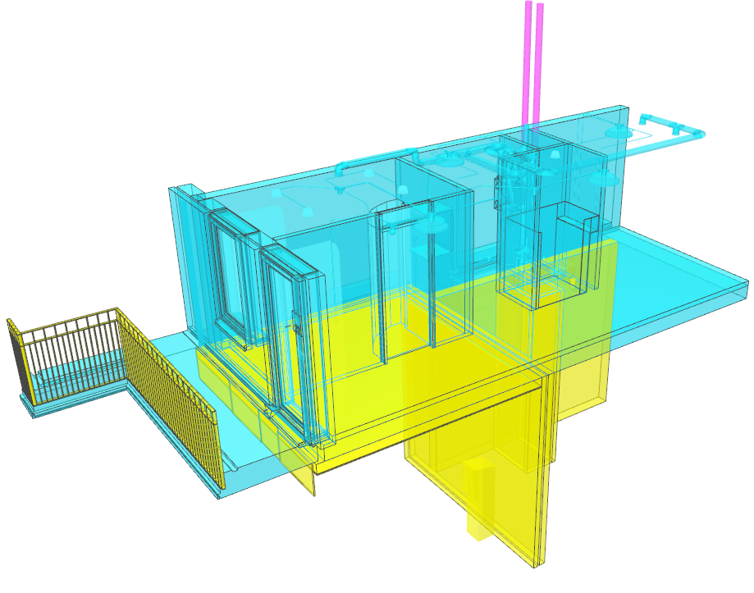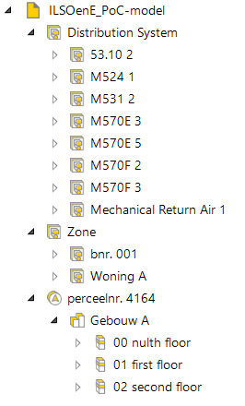

**Results**

The model contains 3 building storeys: 00 nulth floor, 01 first floor and 02 second floor. 00 nulth floor is obviously wrong. The specification should give you this IfcBuildingStorey as a result.

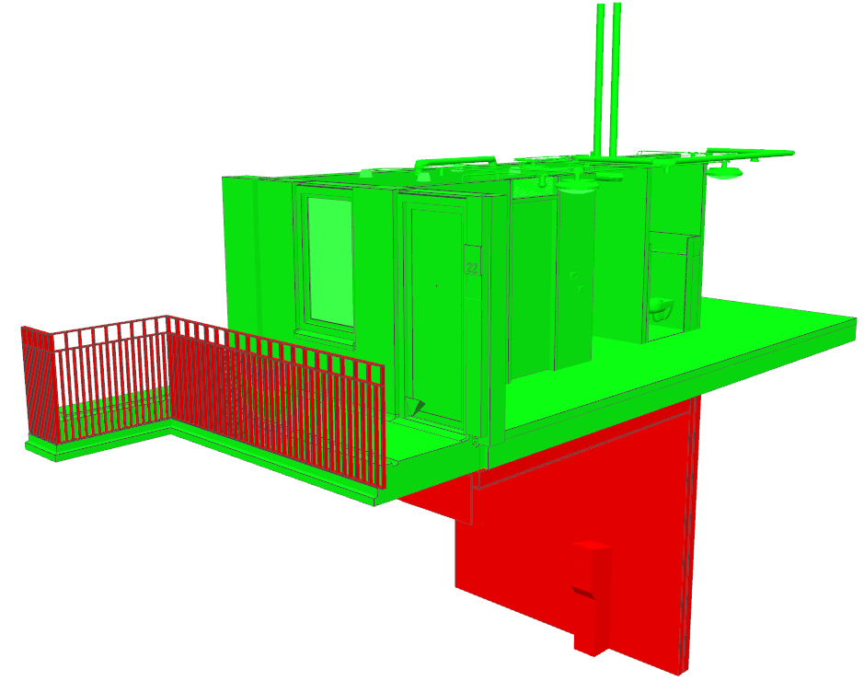

## **ATTRIBUTE: simple RegEx list of correct naming of building storeys - ATT05**

validates the naming of building storeys in with a RegEx pattern <https://standards.buildingsmart.org/IFC/RELEASE/IFC4_3/HTML/lexical/IfcBuildingStorey.htm>

IFC versions: **IFC4X3_ADD2 IFC4 IFC2X3**

**The model MUST contain entities that have**

- IFC class **IFCBUILDINGSTOREY**

**that MEET the following requirements**

- MUST HAVE attribute **Name** **matching the pattern 00 ground floor|01 first floor|02 second floor**

**Instructions**



Add a list of names in the Requirements by use of regular expression



**Results**

The model contains 3 building storeys: 00 nulth floor, 01 first floor and 02 second floor. 00 nulth floor is obviously wrong. The specification should give you this IfcBuildingStorey as a result.



## **ATTRIBUTE: complex RegEx of correct naming of building storeys - ATT06**

validates the naming of building storeys in with a RegEx pattern <https://standards.buildingsmart.org/IFC/RELEASE/IFC4_3/HTML/lexical/IfcBuildingStorey.htm>

IFC versions: **IFC4X3_ADD2 IFC4 IFC2X3**

**The model MUST contain entities that have**

- IFC class **IFCBUILDINGSTOREY**

**that MEET the following requirements**

- MUST HAVE attribute **Name** **matching the pattern [0-2][0-2].*floor**

**Instructions**

Add a list of names in the Requirements by use of regular expression



**Results**

The model contains 3 building storeys: 00 nulth floor, 01 first floor and 02 second floor. 00 nulth floor is obviously wrong. However, with this regular expression you will not find it.



## **ENTITY: Walls must have allowed Predefined Types - ENT01**

These are the Predefined Types. Be aware of not allowed types. <https://standards.buildingsmart.org/IFC/RELEASE/IFC4_3/HTML/lexical/IfcWallTypeEnum.htm>

IFC versions: **IFC4X3_ADD2 IFC4**

**The model MAY contain entities that have**

- IFC class **IFCWALL**

**that MEET the following requirements**

- MUST HAVE IFC class **IFCWALL** with predefined type **ELEMENTEDWALL (or: MOVABLE; PARAPET; PARTITIONING; PLUMBINGWALL; RETAININGWALL; SHEAR; SOLIDWALL; WAVEWALL; USERDEFINED; NOTDEFINED)** (Instructions: Do not allow for POLYGONAL and STANDARD as they are deprecated in the current Schema.)

**Instructions**

Find Walls and check for all of the Predefined Types that are allowed in the Schema.

Use the required cardinality: minOccurs="1" maxOccurs="unbounded".

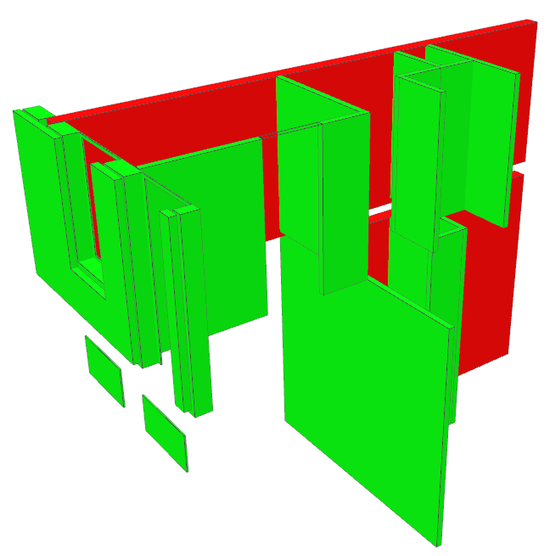

**Results**

The red walls are an IfcWall with predefined type: STANDARD. This enumeration is deprecated in IFC4x3 so this is not in the list and should be the result of this specification.

## **ENTITY: Walls may have allowed Predefined Types - ENT02**

These are the Predefined Types. Be aware of not allowed types. <https://standards.buildingsmart.org/IFC/RELEASE/IFC4_3/HTML/lexical/IfcWallTypeEnum.htm>

IFC versions: **IFC4X3_ADD2 IFC4**

**The model MUST contain entities that have**

- IFC class **IFCWALL**

**that MEET the following requirements**

- MUST HAVE IFC class **IFCWALL** with predefined type **ELEMENTEDWALL (or: MOVABLE; PARAPET; PARTITIONING; PLUMBINGWALL; RETAININGWALL; SHEAR; SOLIDWALL; WAVEWALL; USERDEFINED; NOTDEFINED)** (Instructions: Do not allow for POLYGONAL and STANDARD as they are deprecated in the current Schema.)

**Instructions**

Find Walls and check for all of the Predefined Types that are allowed in the Schema.

Use the optional cardinality: minOccurs="0,"maxOccurs="unbounded".



**Results**

The red walls are an IfcWall with predefined type: STANDARD. This enumeration is deprecated in IFC4x3 so this is not in the list and should be the result of this specification.

## **ENTITY: Walls must not have Predefined Types that are not allowed - ENT03**

* Walls may not have a Predefined Type that is deprecated. <https://standards.buildingsmart.org/IFC/RELEASE/IFC4_3/HTML/lexical/IfcWallTypeEnum.htm>

IFC versions: **IFC4X3_ADD2 IFC4**

**The model MUST NOT contain entities that have**

- IFC class **IFCWALL** with predefined type **POLYGONAL (or: STANDARD)**

**that MEET the following requirements**

- ...

**Instructions**

Find Walls and check for all of the Predefined Types that are not allowed in the Schema.Use the prohibited cardinality: minOccurs="0" maxOccurs="0".IDS documentation reads: requirements are ignored in the verification of models for the prohibited cardinality.



**Results**

The red walls are an IfcWall with predefined type: STANDARD. This enumeration is deprecated in IFC4x3 so this is not in the list and should be the result of this specification.

## **CLASSIFICATION: walls must have CCI classification - CL01**

Checks if the classification is present.This specification has an Entity as applicability.

IFC versions: **IFC4X3_ADD2 IFC4 IFC2X3**

**The model MUST contain entities that have**

- IFC class **IFCWALL**

**that MEET the following requirements**

- MUST HAVE classification **CCI Construction**

- URI: <https://identifier.buildingsmart.org/uri/molio/cciconstruction/1.0/class/L-AD>

**Instructions**

Find all walls, they need to have a CCI classification

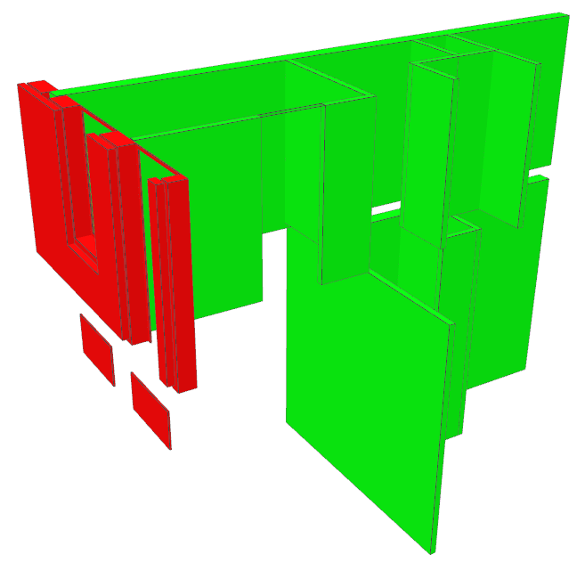

**Results**

The red walls do not have a CCI Classification code.

## **CLASSIFICATION: concrete walls must have CCI classification - CL02**

Checks if the classification is correct. This specification has an attribue as applicability as well as an Entity.

IFC versions: **IFC4X3_ADD2 IFC4 IFC2X3**

**The model MUST contain entities that have**

- IFC class **IFCWALL**

- attribute **Name** **matching the pattern .*beton.\***

**that MEET the following requirements**

- MUST HAVE classification **CCI Construction.L-AD**

- URI: <https://identifier.buildingsmart.org/uri/molio/cciconstruction/1.0/class/L-AD>

**Instructions**

Find all elements containing the word 'beton' (Dutch for concrete) in the Attribute 'Name', they need to have a CCI classification LA-D.

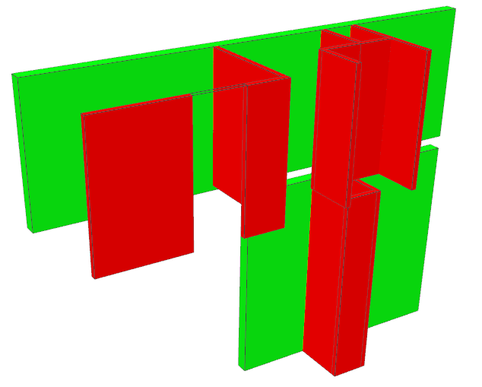

**Result**

The red walls have a name, 22_cellen**beton**_100, that contains the word ‘beton’. The CCI classification is L-B instead of L-AD.

## **CLASSIFICATION: CCI classification L-Ad must be a wall. - CL03**

Reversed specification that wlil find a Slab that has a Wall-code.

IFC versions: **IFC4X3_ADD2 IFC4 IFC2X3**

**The model MUST contain entities that have**

- classification **CCI Construction.L-AD**

**that MEET the following requirements**

- MUST HAVE IFC class **IFCWALL**

**Instructions**

Find all elements with classification L-AD, they must be walls.

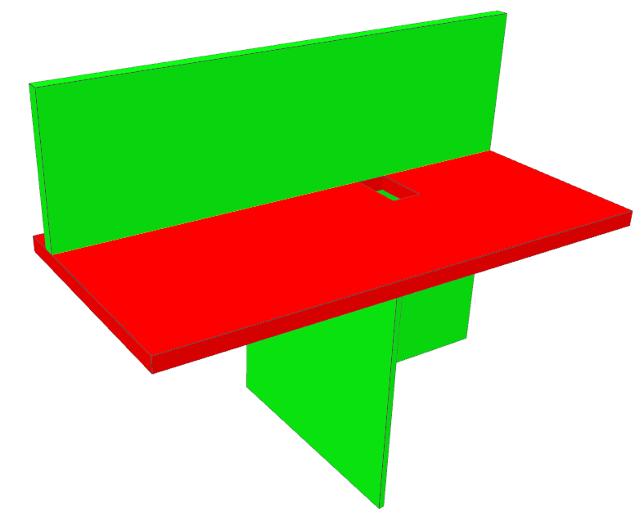

**Result**

The red slab has a CCI classification of L-AD but that’s wrong. L-AD is walls.

## **PROPERTY: IsExternal in Requirement - PROP01**

<https://standards.buildingsmart.org/IFC/RELEASE/IFC4_3/HTML/property/IsExternal.htm>

- If IsExternal in the Pset, this entity should have it defined.

- IFC versions: **IFC4X3_ADD2 IFC4 IFC2X3**

**The model MUST contain entities that have**

- IFC class **IFCWALL (or: IFCSLAB; IFCRAILING; IFCCOVERING; IFCROOF; IFCSPATIALZONE; IFCSTAIR; IFCPLATE; IFCBEAM; IFCCHIMNEY; IFCRAMP; IFCJUNCTIONBOX; IFCCOLUMN; IFCMEMBER; IFCSPACE; IFCBUILDINGELEMENTPROXY; IFCDOOR; IFCWINDOW; IFCSHADINGDEVICE; IFCSIGN; IFCCURTAINWALL)**

**that MEET the following requirements**

- MUST HAVE property **IsExternal** of PSet matching the pattern **Pset_.*Common** **(IFCBOOLEAN)**

**Instructions**

Find out if all entities that have IsExternal in their Common Psets actually have this Property defined.

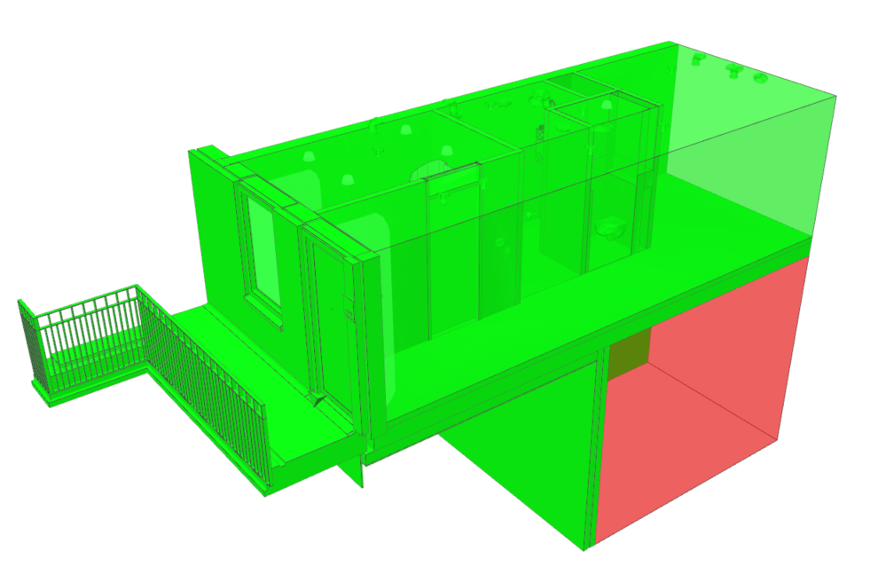

**Result**

One space does not have IsExternal set in the Pset_SpaceCommon.

## **PROPERTY: IsExternal in Applicability - PROP02**

<https://standards.buildingsmart.org/IFC/RELEASE/IFC4_3/HTML/property/IsExternal.htm>

IFC versions: **IFC4X3_ADD2 IFC4 IFC2X3**

**The model MUST contain entities that have**

- property **IsExternal** of PSet **Pset_WallCommon** **(IFCBOOLEAN)**

**that MEET the following requirements**

- MUST HAVE IFC class **IFCWALL** (Instructions: For this specification, IfcWallType has been left out to generate some failures.)

**Instructions**

IsExternal in Pset_WallCommon should be IfcWall

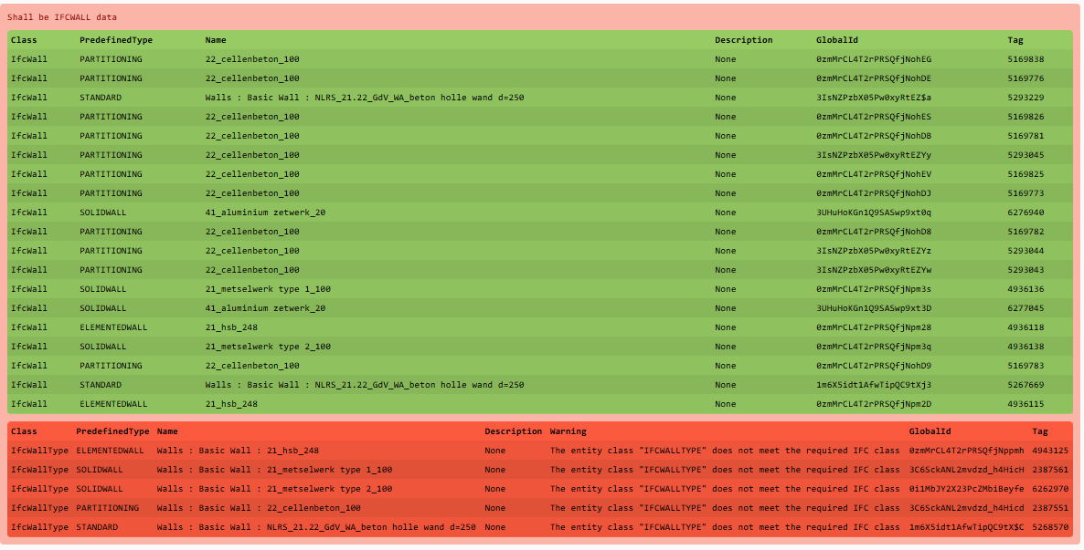

**Result**

This should always be correct right? If your tool supports the validation of Types, you will get mistakes. If not, the specification will pass.

## **PROPERTY: External Railing should have IsExternal = True - PROP03**

<https://data.ketenstandaard.nl/publications/nlsfb/2021/781eb5a2-6424-483d-b050-73a7bbff5775>

IFC versions: **IFC4X3_ADD2 IFC4 IFC2X3**

**The model MAY contain entities that have**

- IFC class **IFCRAILING**

- classification **NL-SfB Tabel 1.34.12**

**that MEET the following requirements**

- MUST HAVE property **IsExternal** of PSet **Pset_RailingCommon** **(IFCBOOLEAN) = true** (Instructions: DataType: IFCBOOLEAN, URI: <https://identifier.buildingsmart.org/uri/buildingsmart/ifc/4.3/prop/IsExternal>

**Instructions**

Find the Railing with NL-SfB ClassificationCode: 34.12: balustrades, handrails; balustrades, outer balustrades'. Outer balustrades should have the property IsExternal = True.

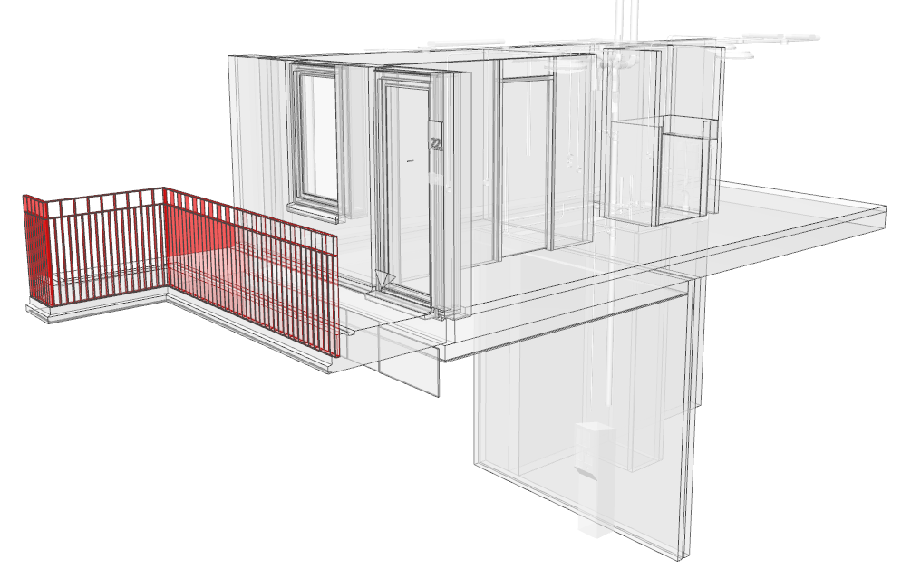

**Result**

IsExternal in Pset_RailingCommon in the Railing is set to False, it should be True.

## **PROPERTY: ticket vending machine is eating my money! - PROP04**

<https://standards.buildingsmart.org/IFC/RELEASE/IFC4_3/HTML/lexical/IfcElectricAppliance.htm>

IFC versions: **IFC4X3_ADD2**

**The model MAY contain entities that have**

- IFC class **IFCELECTRICAPPLIANCE.VENDINGMACHINE**

**that MEET the following requirements**

- MUST HAVE property **TicketVendingMachineType** of PSet **Pset_TicketVendingMachine** **(IFCLABEL) = TICKETVENDINGMACHINE** (Instructions: DataType: IFCLABELTicketVendingMachineType is a enumerated property, chose the correct one from this list: <https://standards.buildingsmart.org/IFC/RELEASE/IFC4_3/HTML/lexical/PEnum_TicketVendingMachineType.htm>

URI: <https://identifier.buildingsmart.org/uri/buildingsmart/ifc/4.3/prop/TicketVendingMachineType>

- MUST HAVE property **TicketStuckRatio** of PSet **Pset_TicketVendingMachine** **(IFCRATIOMEASURE) < 10** (Instructions: DataType: IFCRATIOMEASURE <https://standards.buildingsmart.org/IFC/RELEASE/IFC4_3/HTML/lexical/Pset_TicketVendingMachine.htm>

URI: <https://identifier.buildingsmart.org/uri/buildingsmart/ifc/4.3/prop/TicketStuckRatio>

- MUST HAVE property **MoneyStuckRatio** of PSet **Pset_TicketVendingMachine** **(IFCRATIOMEASURE) ≥ 50** (Instructions: DataType: IFCRATIOMEASURE <https://standards.buildingsmart.org/IFC/RELEASE/IFC4_3/HTML/lexical/Pset_TicketVendingMachine.htm>

URI: <https://identifier.buildingsmart.org/uri/buildingsmart/ifc/4.3/prop/MoneyStuckRatio>

- MUST HAVE property **Manufacturer** of PSet **Pset_ManufacturerTypeInformation** **(IFCLABEL) = WPS** (Instructions: DataType: IFCLABEL <https://standards.buildingsmart.org/IFC/RELEASE/IFC4_3/HTML/lexical/Pset_ManufacturerTypeInformation.htm>

URI: <https://identifier.buildingsmart.org/uri/buildingsmart/ifc/4.3/prop/Manufacturer>

**Instructions**

Find the Ticket vending machine and add Properties Manufacturer, TicketVendingMachineType, TicketStuckRatio and MoneyStuckRatio. Set the ratios as bounds.

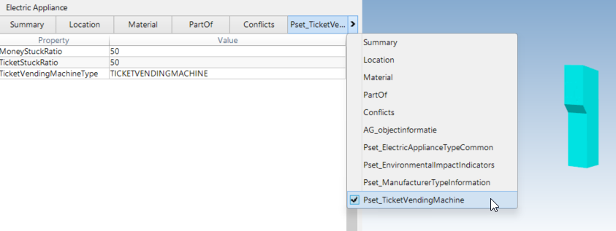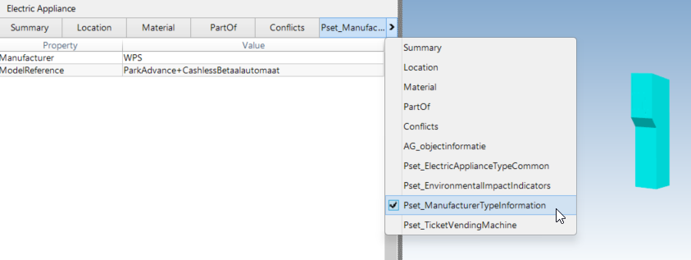

**Result**

TicketStuckRatio should generate a mistake. Test a few values that are equal to, lesser or greater than 50 to see how your specification works.

## **MATERIAL: specific element must have a specific name - MAT01**

Validating materials is usually never done like this. But if a tool does not support RegEx, this is a simple test.

IFC versions: **IFC4X3_ADD2 IFC4**

**The model MUST contain entities that have**

- IFC class **IFCWALL.SOLIDWALL**

- attribute **Name** **= 21_metselwerk type 1_100**

**that MEET the following requirements**

- MUST HAVE material **steenachtig_baksteen_steen_roodroze**

URI: <https://identifier.buildingsmart.org/uri/nkt/naakt/2.4/class/steenachtig_baksteen_steen>

**Instructions**

Find walls with name '21_metselwerk type 1_100', the Material should be steenachtig_baksteen_steen_roodroze

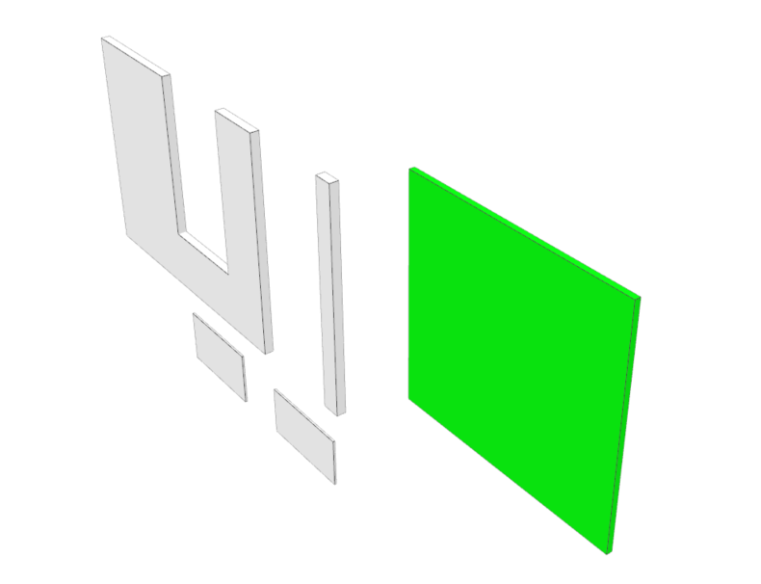

**Result**

The correct wall should be found

## **MATERIAL: brickwork should start with steenachtig_baksteen_steen - MAT02**

Usually you need to filter elements and then, the materialname must have a specific syntax ore a specific word in the name. Regular expressions are key in these type of specifications.

IFC versions: **IFC4X3_ADD2 IFC4**

**The model MUST contain entities that have**

- IFC class **IFCWALL.SOLIDWALL**

- attribute **Name** **matching the pattern .*metselwerk.\***

**that MEET the following requirements**

- MUST HAVE material matching the pattern **steenachtig_baksteen_steen.\***

**Instructions**

Find walls with a name that contains 'metselwerk', the Material should start with steenachtig_baksteen_steen

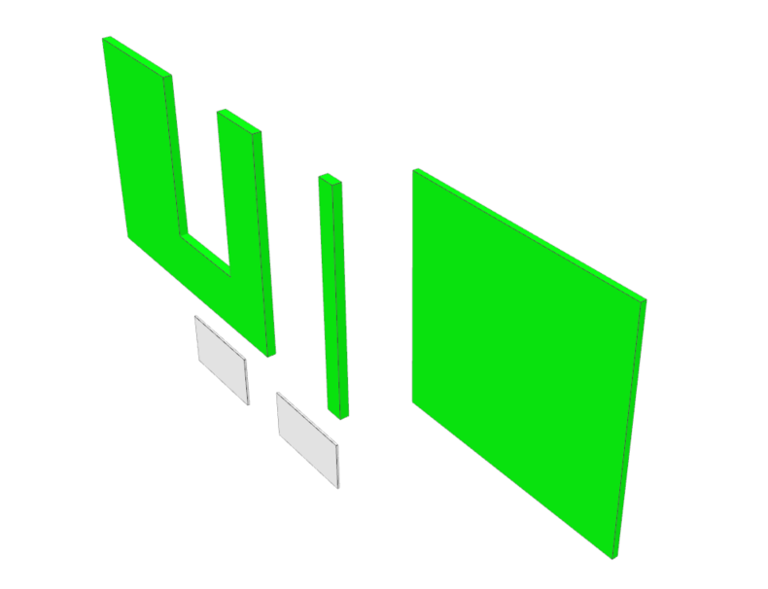

**Result**

The correct walls will be found.

## **MATERIAL: a materialname must have a specific property - MAT03**

https://standards.buildingsmart.org/IFC/RELEASE/IFC4_3/HTML/lexical/PEnum_AssemblyPlace.htm

IFC versions: **IFC4X3_ADD2 IFC4**

**The model MUST contain entities that have**

- material matching the pattern **(beton|gips|hout|ntb|generiek)_.*_prefab-element.\***

**that MEET the following requirements**

- MUST HAVE property **AssemblyPlace** of PSet **Pset_ManufacturerTypeInformation** **(IFCLABEL) = FACTORY**

URI: <https://identifier.buildingsmart.org/uri/buildingsmart/ifc/4.3/prop/AssemblyPlace>

**Instructions**

Find elements with a materialname containing 'prefab-element'. They should have the AssemblyPlace property set as FACTORY in Pset_ManufacturerTypeInformation

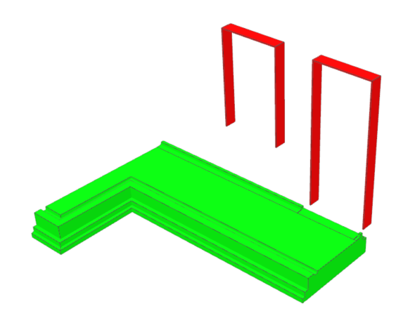

**Result**

The concrete slab is a prefab element, assembled in the Factory. The gypsum boards are prefabicated pieces but do not have the property AssemblyPlace set.

## **PARTOF: MEP part of an IfcDistributionsystem - PO01**

IFC versions: **IFC4X3_ADD2 IFC4**

**The model MUST contain entities that have**

- IFC class **IFCPIPEFITTING (or: IFCPIPESEGMENT)**

**that MEET the following requirements**

- MUST HAVE relationship **IFCRELASSIGNSTOGROUP** with IFC class **IFCDISTRIBUTIONSYSTEM.DOMESTICCOLDWATER**

**Instructions**

Find some pipes, they must be part of an IfcDistributionSystem

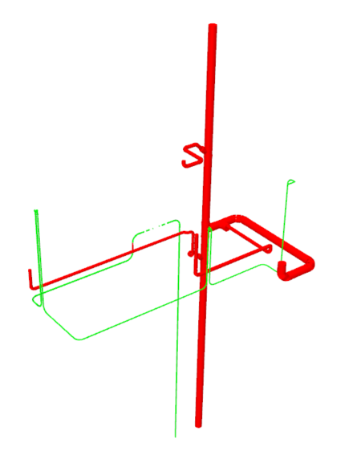

**Result:**

Some pipesegments and fittings are not part of the IfcDistributionSystem

## **PARTOF: A smokesensor must be in a space - PO02**

IFC versions: **IFC4X3_ADD2 IFC4**

**The model MUST contain entities that have**

- IFC class **IFCSENSOR.SMOKESENSOR**

**that MEET the following requirements**

- MUST HAVE relationship **IFCRELCONTAINEDINSPATIALSTRUCTURE** with IFC class **IFCSPACE**

**Instructions**

Find the IfcSensor.SMOKESENSOR that must be contained it a spatial structure, an IfcSpace

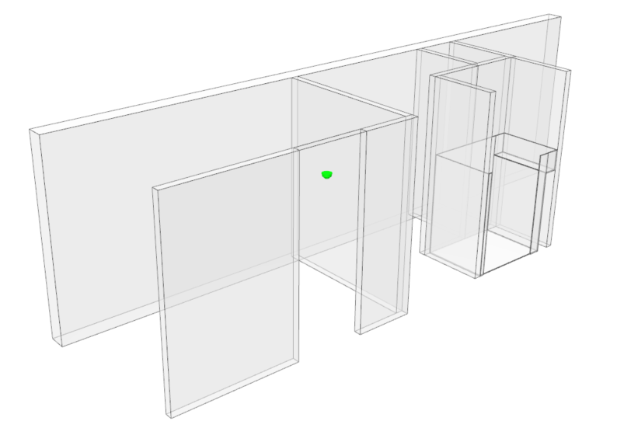

**Result**

The Smokedetector is part of a space.

(In IDS version 1.0 we cannot further define what space it should be part of.)

## **PARTOF: A building must be build on a site - PO03**

IFC versions: **IFC4X3_ADD2 IFC4 IFC2X3**

**The model MUST contain entities that have**

- IFC class **IFCBUILDING**

**that MEET the following requirements**

- MUST HAVE relationship **IFCRELAGGREGATES** with IFC class **IFCSITE**

**Instructions**

Find the IfcBuilding, it should aggregate into an IfcSite

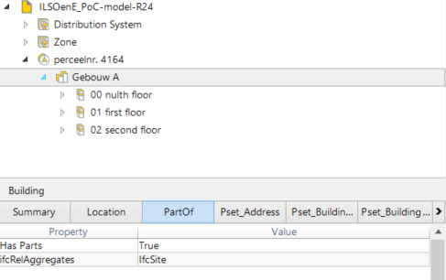

**Result**

The building has a relation to the site it is on.

## **ENTITY: Walls must not have Predefined Types that are not allowed (illegal specification)) - INVALID01**

These are the Predefined Types. Be aware of not allowed types. <https://standards.buildingsmart.org/IFC/RELEASE/IFC4_3/HTML/lexical/IfcWallTypeEnum.htm>

IFC versions: **IFC4X3_ADD2**

**The model MUST NOT contain entities that have**

- IFC class **IFCWALL**

**that MEET the following requirements**

- MUST HAVE IFC class **IFCWALL** with predefined type **POLYGONAL (or: STANDARD)** (Instructions: Do not allow for POLYGONAL and STANDARD as they are deprecated in the current Schema.)

**Instructions**

Find Walls and check for all of the Predefined Types that are not allowed in the Schema.Use the prohibited cardinality: minOccurs="0" maxOccurs="0".IDS documentation reads: requirements are ignored in the verification of models for the prohibited cardinality. This is not really well implemented in most tools yet? Tools usually understand this method and will read the requierements anyway.



**Result**

Red walls are IfcWall.STANDARD.

## **PROPERTY: ticket vending machine is eating my money! - INVALID02**

https://standards.buildingsmart.org/IFC/RELEASE/IFC4_3/HTML/lexical/IfcElectricAppliance.htm

IFC versions: **IFC4X3_ADD2**

**The model MAY contain entities that have**

- IFC class **IFCELECTRICAPPLIANCE.VENDINGMACHINE**

**that MEET the following requirements**

- MUST NOT HAVE property **MoneyStuckRatio** of PSet **Pset_TicketVendingMachine** **(IFCRATIOMEASURE) > 10** (Instructions: DataType: IFCRATIOMEASUREhttps://standards.buildingsmart.org/IFC/RELEASE/IFC4_3/HTML/lexical/Pset_TicketVendingMachine.htm, URI: https://identifier.buildingsmart.org/uri/buildingsmart/ifc/4.3/prop/MoneyStuckRatio)

- MUST NOT HAVE property **TicketStuckRatio** of PSet **Pset_TicketVendingMachine** **(IFCRATIOMEASURE) < 50** (URI: https://identifier.buildingsmart.org/uri/buildingsmart/ifc/4.3/prop/TicketStuckRatio)

**Instructions**

Find the Ticket vending machine and add Properties Manufacturer, TicketVendingMachineType, TicketStuckRatio and MoneyStuckRatio.Set the ratios as bounds.



**Result**

An alternative way of validating a model on restrictions. Something should be less than 10… or somehting cannot be greater or equal to 10. Same thing, use what works best for you and the tools you are using.

## **PARTOF: Door fills wall - INVALID03**

IFC versions: **IFC4X3_ADD2**

**The model MUST contain entities that have**

- IFC class **IFCDOOR**

**that MEET the following requirements**

- MUST HAVE relationship **IFCRELVOIDSELEMENT IFCRELFILLSELEMENT** with IFC class **IFCWALL**

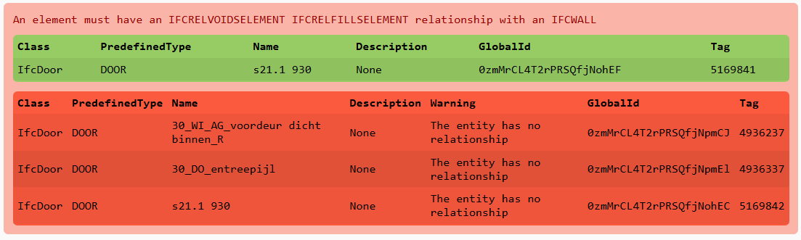

**Result**

Some elements are nested elements that do not void or fill an element. The one door in the interior wall does. **IFCRELVOIDSELEMENT IFCRELFILLSELEMENT** is a list and the IDS audit tool generates a mistake since you should choose one of the two. However, the tools used to create anvalidate this do not agree with this somehow.